Appendix:
Figure 1. CogTutor home interface showing the cognitive scaffolding workflow.
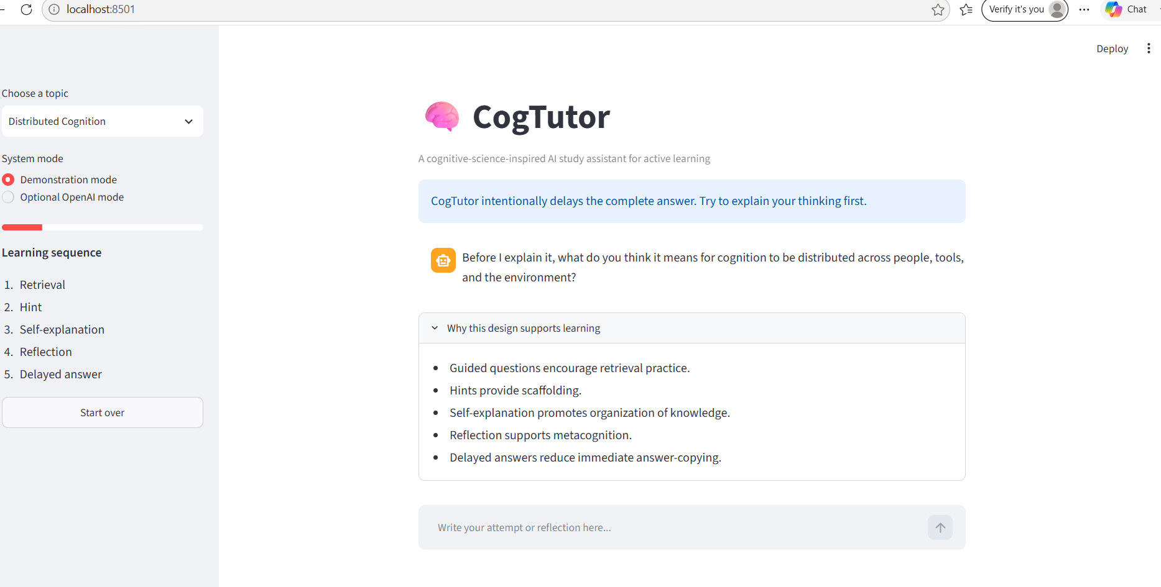

Figure 2. Student attempts retrieval before receiving assistance.
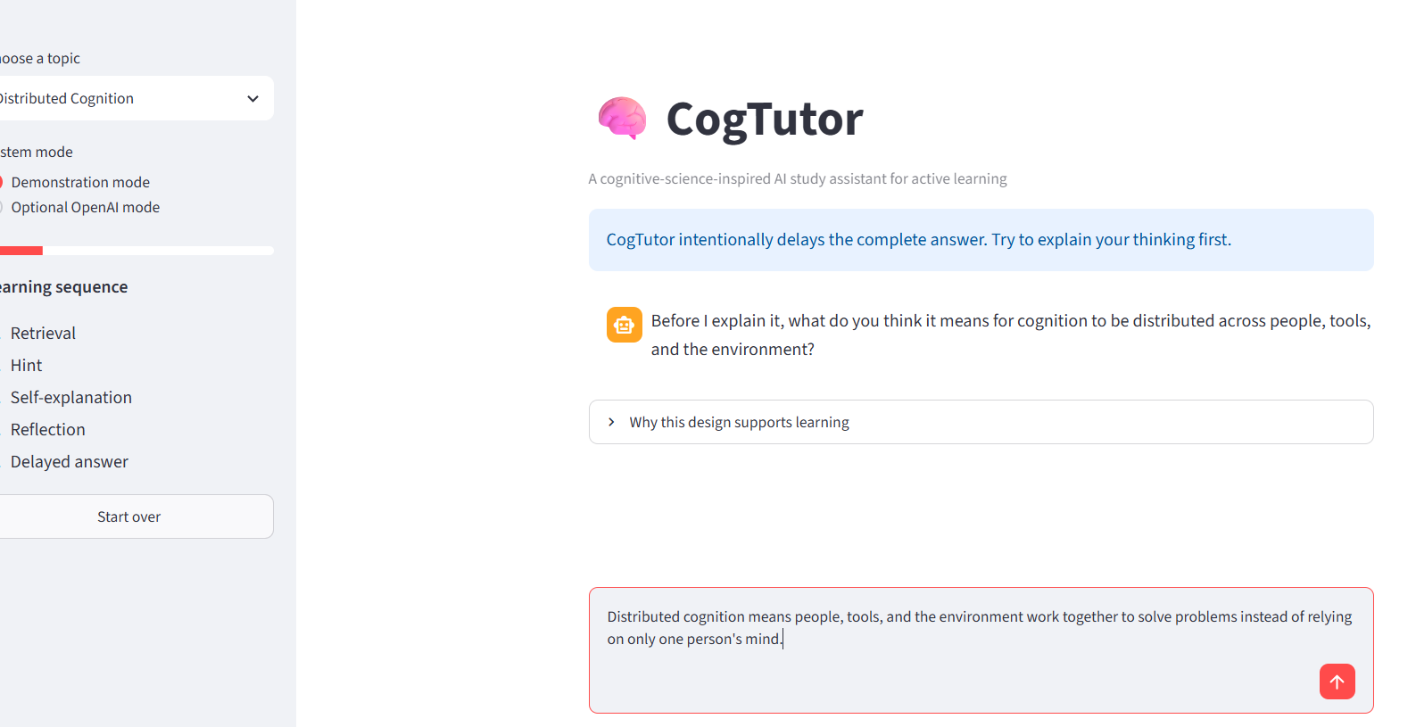

Figure 3. Incremental hint provided after learner retrieval attempt.
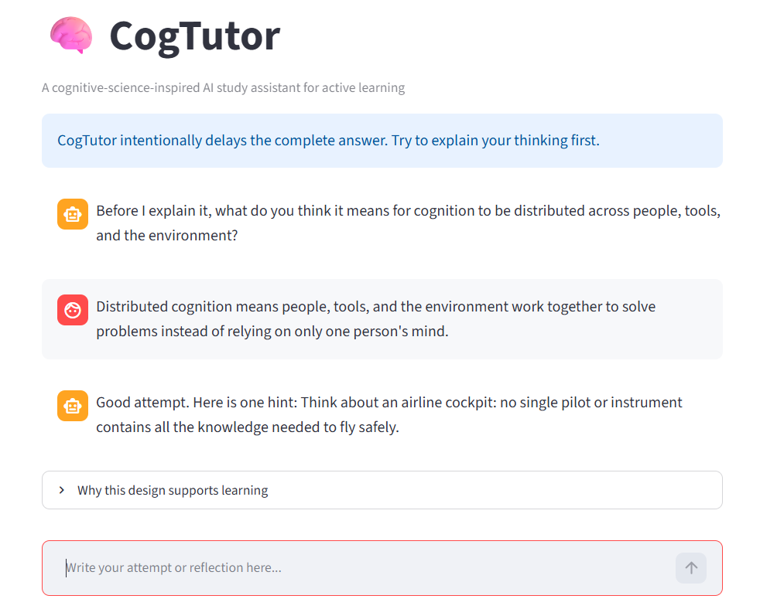
Figure 4. Self-explanation stage encouraging deeper learning.
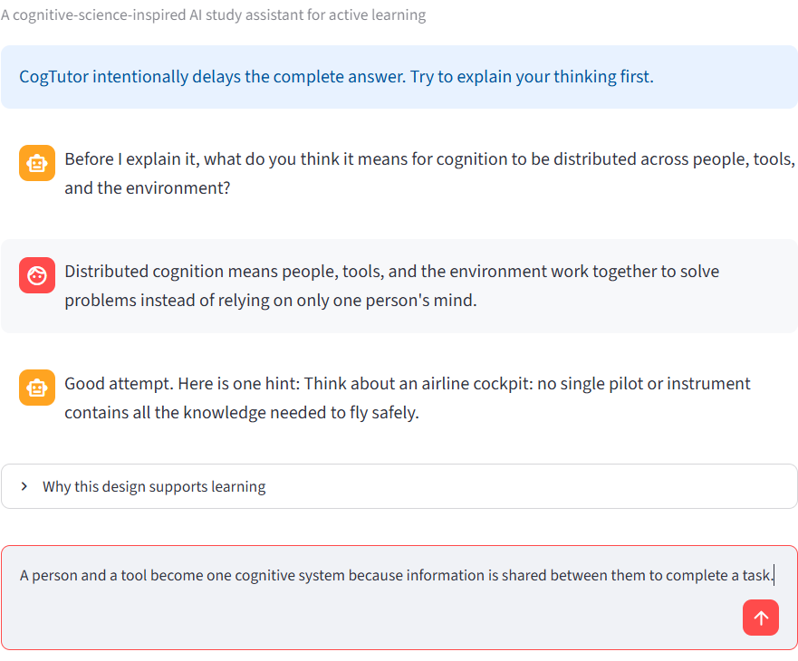
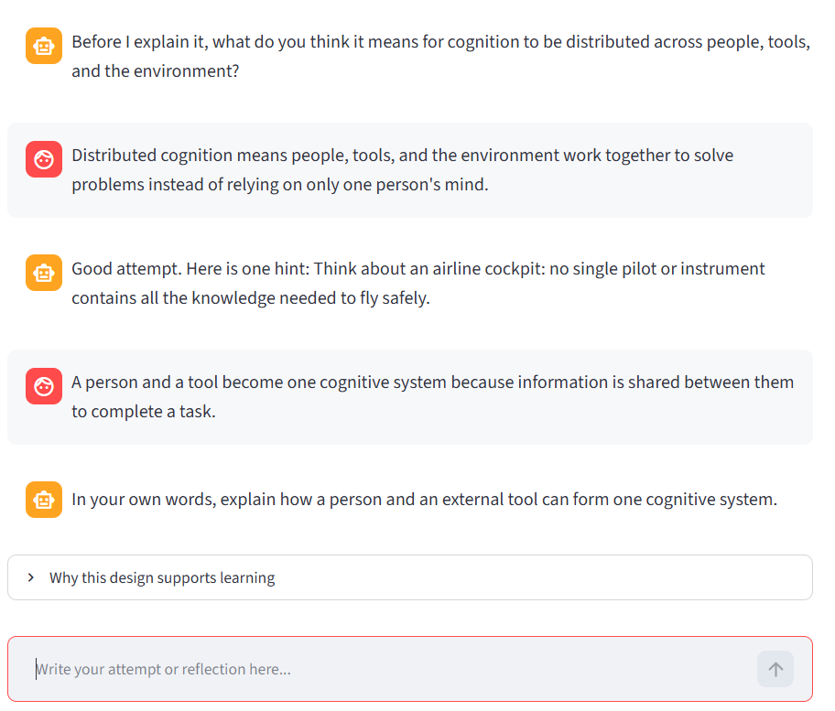
Figure 5. Metacognitive reflection encouraging self-monitoring.
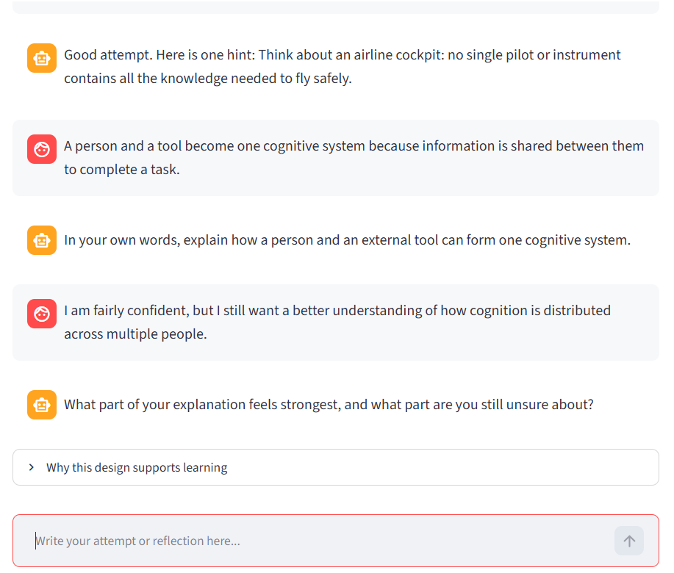
Figure 6. Delayed explanation shown after active learning activities are completed.
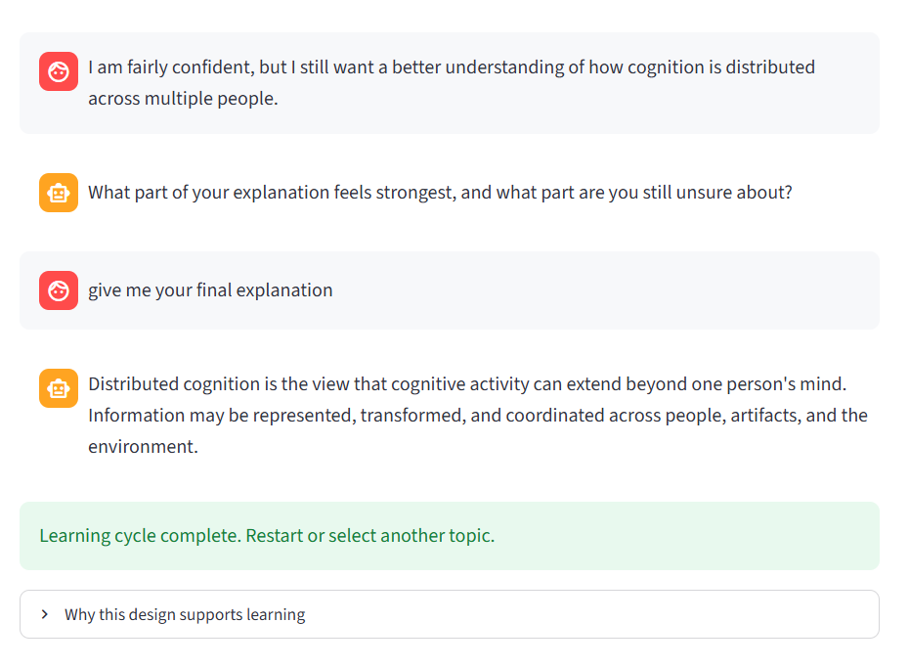
Fig. 7. CogTutor learning dashboard summarizing topic completion, learning progress, completed stages, and status.

